Yates Avenue Public School
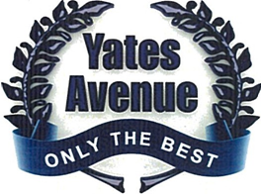

Information Handbook
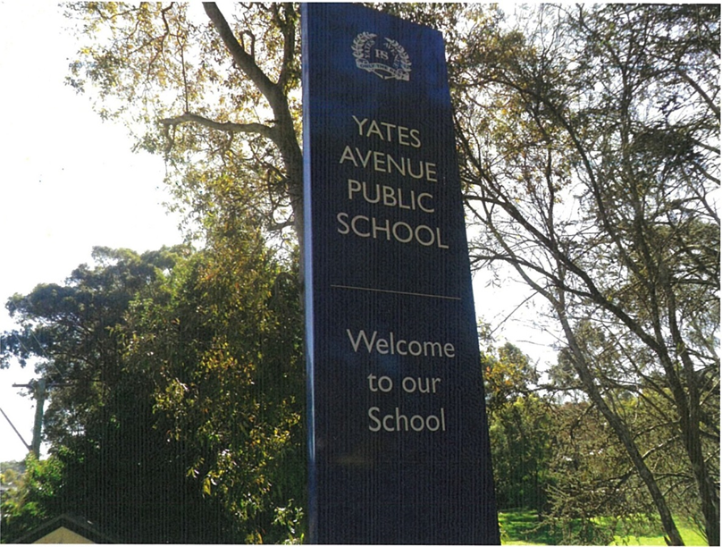

GENERAL INFORMATION

Yates Avenue Public School
71 Yates Avenue
Dundas, N.S.W. 2117

Telephone (02) 9874 6302
Fax (02) 9804 6260

Website www.yatesave-p.schools.nsw.edu.au
Email yatesave-p.school@det.nsw.edu.au

PRINCIPAL Ms. Tracey Lee

ASSISTANT PRINCIPALS Mrs. Diane Keeffe

For appointments telephone:

SCHOOL ADMINISTRATIVE SUPPORT STAFF

Mrs. Copping
Ms. Rose
Mrs. Salter

Office Hours: 8:30am - 3:30pm (Monday- Friday)

School Hours: 9:00am - 3:00pm

School officially commences at 8:30am and a teacher is on duty from that time.

Children should not arrive at school before 8:30am.

Bell Times: 8:30am - 9:00am Teacher on Duty
9:00am – 11:15am Class
11:15am-12:10pm Lunch
12:10pm- 1:40pm Class
1:40pm- 2:00pm Afternoon Tea
2:00pm- 3:00pm Class

OOSH

Should parents need supervision for their children before or after school hours, we have an Out of School Hours Centre (OOSH) on the school grounds.
Please contact on 9804 7541.

Attendance

Parents have a legal responsibility to ensure that their children from the age of six years attend school on a regular basis.

Arriving Late or Leaving Early

Late Arrival
If your child/ren arrives late s/he must report to the Office to collect a pink slip to hand to the classroom teacher with the recorded arrival time.

Early Leaver
If your child/ren has to leave early, you need to report to the office and sign your child/ren out in the Early Leavers Book; a leaving time is recorded and a pink slip to hand to the classroom teacher.

Bus Passes

Depending upon State Government requirements, your child may be eligible for a bus pass if travelling directly to and from school.

Government regulations state that students in Years 3-6, must live at least (l.6km) from school "as the crow flies" before being eligible for a bus pass.

Forms for both Government and Private bus travel may be obtained from the Office and returned when fully completed.

Communication

A school newsletter, "Yates Matters", is sent home fortnightly (even weeks). It contains information for parents on the happenings of our school. Other specific notes will be sent home as the need arises. Please check your child’s bag regularly.

Canteen

The Canteen Committee is a sub-committee of the P & C and is responsible for the management of the Canteen and the implementation of DoE Healthy Canteen policy.
The Canteen provides a lunch service Monday, Tuesday and Friday each week and a snack service each day of the week as well as a "SPECIALS" day once a term.

The Canteen is run on a voluntary basis and your help would be appreciated. The Canteen profits are returned the P & C to go towards buying equipment, educational material etc. for our children. If you volunteer in the canteen please remember to sign the Visitor’s Book in the school Office when you arrive for duty.

English as an Additional Language or dialect (Eal/D)

An EAD/L teacher works with class teachers in organising class programs for students who speak another language. The EAL/D teacher works within the classroom,small groups or individual students.

Positive Behaviour for Learning

The school’s discipline code is set out in a separate document. This is available upon request and contains information about Students ‘Rights and Responsibilities, the Discipline system and Merit System of Yates Avenue.

The school expectations have been developed by the SRC, in consultation with the teachers and the community. They are:

BE RESPONSIBLE BE A LEARNER

BE RESPECTFUL BE SAFE

Curriculum

The Primary Curriculum, (K–6), is organised into Six Key Learning Areas (KLAs).
- English
- Mathematics
- Science
- History
- Geography
- Creative Arts (Music, Dance, Drama and Visual Arts)
- Personal Development, Health and Physical Education

First Aid and Sick Students

Occasionally, children become sick or injured at school. Basic first aid is administered and accommodated in Sick Bay.

Parents are contacted on a needs basis so please ensure contact details are up to date.

On-going Medication

Policy statements from the NSW Department of Education outline procedures which must be followed when a child requires ongoing daily medication to be administered at school.
- A Request for Administering Prescribed Medication to Student form is to be completed by a parent at the office.

Medication required for a short period

If a child is prescribed medication for a short period of time parents need to complete a Request for Administering Medication to Student form available from the office.

Allergies/ Anaphylaxis/ Asthma

A completed ASCIA Action Plan/Asthma Plan and/or Individual Health Care Plan outlining procedures to be followed must be supplied by your family DOCTOR as well as appropriate medication.

Immunisation

The New South Wales Department of Health recommends that children entering school should be immunised. It is important to obtain and keep a written record of your child’s immunization and provide upon enrolment.

Learning Support Team
The school’s Learning Support Team meets regularly to provide support and guidance for students experiencing difficulties and appropriate educational plans developed to cater for individual needs.

Learning and Support Teacher (LaST)

The LaST supports individual students who are experiencing difficulties. The class teacher and LaST assess the students’ needs and jointly plan lessons for targeted students.

Library

Students attend weekly library lessons where they are able to borrow books. Each student must have a library bag for borrowing. Library bags with the school emblem are available to purchase from the School Office.
Lost Property
Lost property is located in the foyer of E Block: Unclaimed items remaining at the end of each term are donated to the uniform shop or appropriate charities.
Money Collection
Please send correct money in a sealed envelope with your child’s name, class and activity clearly marked on the front of an envelope.

Parents' and Citizens' Association

The P & C meet on the last Monday of each month in the P & C Room (I Block) at 6.30p.m. All parents are welcome to attend.

School Counsellor

Our school has regular access to the expertise of a school counsellor who gives guidance to the students, parents and teachers. Please contact the school office to make an appointment.

Special Religious Education

These classes are held every Friday:
9:00am - 9:30am Y ears K - 2
9:30am – 10:05am Years 3 - 6

The following religions are catered for: Combined Anglican/Protestant, Roman Catholic, and Islamic. A note is required if you wish to change your child's scripture class.

Sporting Activities

The school has four Sports Houses. They are named after famous people who made a significant contribution to the local area.

- Rumsey (Blue) is named after Herbert Rumsey (1866-1 956), who had a seed and nursery business in the area early this century.

- Marsden (Green) is named after Samuel Marsden (1764- 1848) , who made important contributions to the agricultural development of New South Wales and who played a prominent part in the public affairs of the colony.

- Spurway (Red) is named after George Spurway (1806- 1885), who donated land to the Council of Education for the first Dundas National School, the predecessor of Yates Avenue P.S.

- Stewart (Yellow) is named after Sir Frederick Stewart (1884-1961), who established Stewart House at Curl Curl and Lottie Stewart Hospital.

Uniform Code

Girls' Summer Uniform  Blue and white check dress with white collar.  White Socks.  Black school shoes.  Royal blue school hat | Boys' Summer Uniform  Short-sleeved mid-blue shirt.  Grey shorts.  Grey socks.  Black school shoes.  Royal blue school hat.
Girls' Winter Uniform  Blue checked tunic with kick pleat and side seam pocket.  Long-sleeved lemon shirt.  Royal blue v-neck school jumper and/or zippered jacket with school crest.  White socks or navy tights.  Black school shoes.  Royal blue school hat. | Boys' Winter Uniform  Long grey trousers.  Long-sleeved mid-blue shirt.  Royal blue v-neck school jumper or zippered jacket.  Grey socks and Black school shoes.  Royal blue school hat.
Girls' Sports Uniform (K-6)  Yellow Polo-necked shirt with school crest.  Royal blue skorts / Royal blue shorts / tracksuit pants  White socks  White joggers  Royal blue school hat. | Boys' Sports Uniform (K-6)  Yellow Polo-necked shirt with school crest.  Royal blue shorts / tracksuit pants.  White socks.  White joggers.  Royal blue school hat.

The Uniform Shop is open on Friday mornings from 8:45a m – 9:15am. Most uniform items are available. Orders and money may be sent into the School Office if parents are unable to attend.

